**Different ways of command line parameters or arguments:**

* If we are sending the parameters long with the script is called command line parameters
* We can also pass the arguments like below

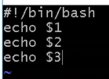

* And the output will be as below

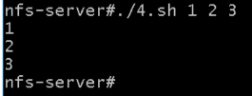

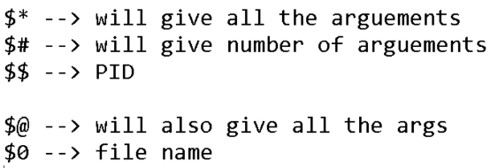



* If we use these arguments, $* will print all the arguments given in command
* And $# prints the number of arguments as below



* $* would be useful when we are trying to restrict the user to enter 3 values and if user enters only 2 values
* At that time, we can use if condition as $* is not equals to 3 then fail the script
* $$ is used to print the PID
* $0 prints the file name

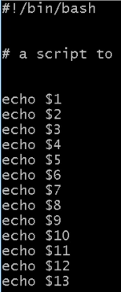

* If we have given the arguments like above and tried to print as below



* It is not printing the 10,11,12,13 args values. Because it can print up to 9 and from 10 it takes like echo $1 which value is 1 and it takes 0 which is next to 1
* Below is another example for that



* Below is the output

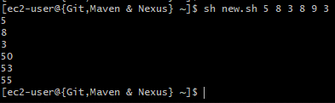

* So, if we want to print, then we need to give them in curly braces as below

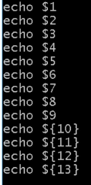

* Now it works